- 8 PUZZLE PROBLEM

AIM
To solve the 8-Puzzle Problem by comparing the given initial state with the goal state and determining the number of misplaced tiles using Python

CODE
from collections import deque

print("Name : M.Rashika")
print("Reg No: 192573010\n")

goal=((1,2,3),(4,5,6),(7,8,0))
start=((1,2,3),(4,0,6),(7,5,8))

q=deque([(start,[])])
v=set()

while q:
s,p=q.popleft()
if s==goal:
print("Solution Found!\n")
for x in p+[s]:
for r in x:
print(r)
print()
break
if s in v:
continue
v.add(s)
i,j=[(a,b) for a in range(3) for b in range(3) if s[a][b]==0][0]
for di,dj in [(-1,0),(1,0),(0,-1),(0,1)]:
ni,nj=i+di,j+dj
if 0<=ni<3 and 0<=nj<3:
t=[list(r) for r in s]
t[i][j],t[ni][nj]=t[ni][nj],t[i][j]
q.append((tuple(map(tuple,t)),p+[s]))

OUTPUT

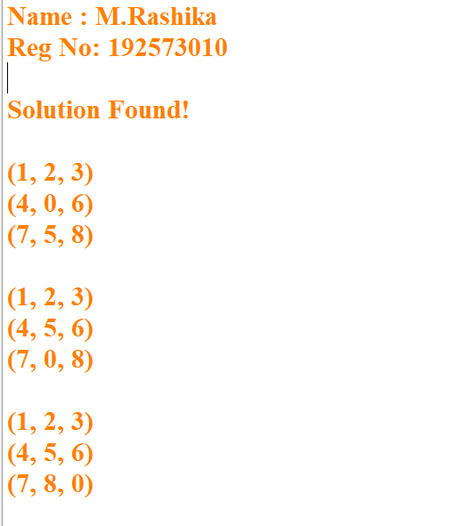
2.8 QUEEN PROBLEM

AIM
To solve the 8-Queen Problem using Backtracking in Python by placing eight queens on an 8 × 8 chessboard such that no two queens attack each other.

CODE:
print("8-QUEENS PROBLEM")
print("Name : M.Rashika")
print("Reg No: 192573010\n")

x = [0]*8

def q(r):
if r == 8:
for i in x:
print("."*i + "Q" + "."*(7-i))
return
for c in range(8):
if all(x[i]!=c and abs(x[i]-c)!=r-i for i in range(r)):
x[r]=c
q(r+1)
return

OUTPUT
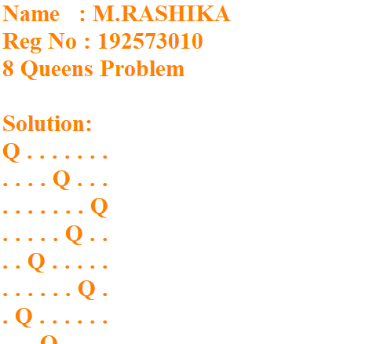
3.WATER JUG PROBLEM

AIM
To solve the Water Jug Problem using Python by finding the sequence of steps required to obtain the required amount of water.

CODE

print("WATER JUG PROBLEM")
print("Name : M.Rashika")
print("Reg No: 192573010\n")

x, y = 0, 0
while y != 2:
if x == 0:
x = 4
print("Fill 4L Jug:", x, y)
elif y == 3:
y = 0
print("Empty 3L Jug:", x, y)
else:
t = min(x, 3-y)
x -= t
y += t
print("Pour:", x, y)

print("\nGoal Achieved: 2 Litres in 3L Jug")print("Target Reached!")

OUTPUT
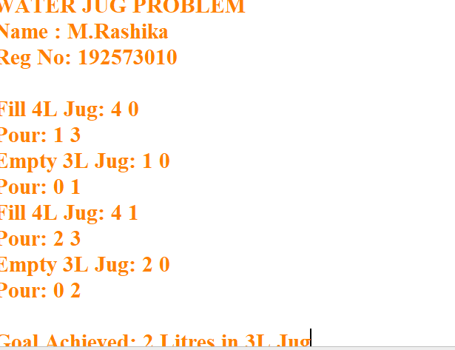

4.VACUUM CLEANER PROBLEM

AIM
To implement the Vacuum Cleaner Problem using Python and simulate a simple intelligent agent that cleans all dirty rooms
CODE
print("VACUUM CLEANER PROBLEM")
print("Name : M.Rashika")
print("Reg No: 192573010\n")

rooms = {'A':'Dirty', 'B':'Dirty'}

for room in rooms:
if rooms[room] == 'Dirty':
print("Cleaning Room", room)
rooms[room] = 'Clean'

print("\nFinal Status:")
print(rooms)

OUTPUT
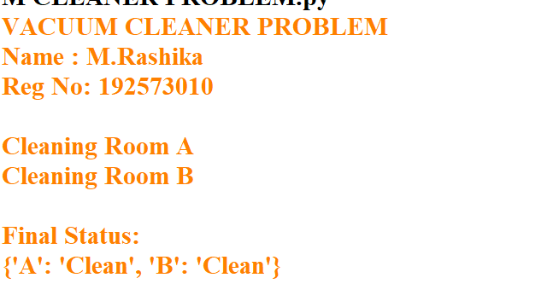

5.BREADTH FIRST SEARCH (BFS)

AIM
To implement the Breadth First Search (BFS) algorithm in Python to traverse all the vertices of a graph level by level

CODE
print("BREADTH FIRST SEARCH (BFS)")
print("Name : M.Rashika")
print("Reg No: 192573010\n")

graph = {
'A':['B','C'],
'B':['D','E'],
'C':['F'],
'D':[],
'E':[],
'F':[]
}

visited = []
queue = ['A']

while queue:
node = queue.pop(0)
if node not in visited:
print(node, end=" ")
visited.append(node)
queue.extend(graph[node])

OUTPUT

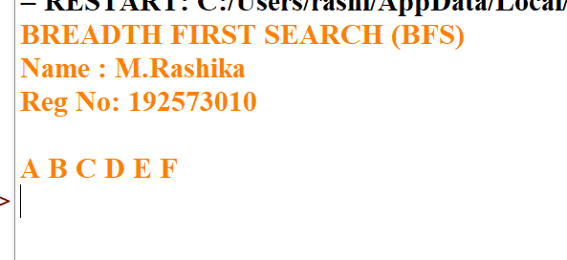

6.DEPTH FIRST SEARCH (DFS)

AIM
To implement the Depth First Search (DFS) algorithm in Python to traverse all the vertices of a graph using recursion.

CODE
print("DEPTH FIRST SEARCH (DFS)")
print("Name : M.Rashika")
print("Reg No: 192573010\n")

graph = {
'A':['B','C'],
'B':['D','E'],
'C':['F'],
'D':[],
'E':[],
'F':[]
}

visited = []

def dfs(node):
if node not in visited:
print(node, end=" ")
visited.append(node)
for i in graph[node]:
dfs(i)

dfs('A')

OUTPUT
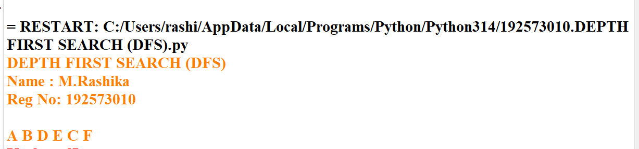

. MISSIONARIES AND CANNIBALS PROBLEM

AIM;
To solve the Missionaries and Cannibals problem using Python by safely transporting all missionaries and cannibals across the river without ever allowing cannibals to outnumber missionaries on either bank.
CODE
print("MISSIONARIES AND CANNIBALS PROBLEM")
print("Name : M.Rashika")
print("Reg No: 192573010\n")

from collections import deque

q = deque([((3,3,1), [])])
v = set()
m = [(1,0),(2,0),(0,1),(0,2),(1,1)]

while q:
(a,b,c), p = q.popleft()
if (a,b,c) == (0,0,0):
print("Solution Found\n")
print(p + [(a,b,c)])
break
if (a,b,c) in v:
continue
v.add((a,b,c))
for x,y in m:
A,B,C = (a-x,b-y,0) if c else (a+x,b+y,1)
if 0<=A<=3 and 0<=B<=3 and (A==0 or A>=B) and ((3-A)==0 or (3-A)>=(3-B)):
q.append(((A,B,C), p+[(a,b,c)]))

OUTPUT
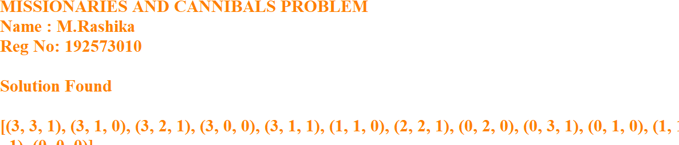

8. TRAVELLING SALESMAN PROBLEM

AIM
To solve the Travelling Salesman Problem using Python by finding the shortest route that visits each city exactly once and returns to the starting city.

CODE
print("TRAVELLING SALESMAN PROBLEM")
print("Name : M.Rashika")
print("Reg No: 192573010\n")

from itertools import permutations

graph = [
[0,10,15,20],
[10,0,35,25],
[15,35,0,30],
[20,25,30,0]
]

n = 4
cost = 999
path = ()

for p in permutations(range(1, n)):
c = graph[0][p[0]]
for i in range(len(p)-1):
c += graph[p[i]][p[i+1]]
c += graph[p[-1]][0]

if c < cost:
cost = c
path = (0,) + p + (0,)

print("Minimum Cost =", cost)
print("Path =", path)

OUTPUT
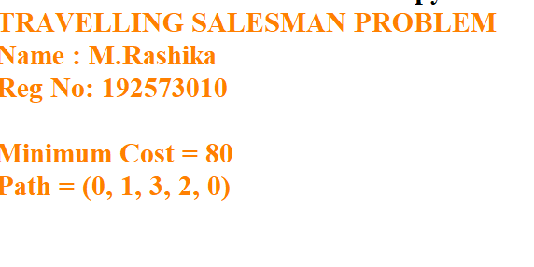
9. CRYPT ARITHMETIC PROBLEM

AIM
To solve a Crypt Arithmetic problem using Python by assigning unique digits to letters such that the arithmetic equation is satisfied.

CODE
print("CRYPT ARITHMETIC PROBLEM")
print("Name : M.Rashika")
print("Reg No: 192573010\n")

from itertools import permutations

letters = "SENDMORY"
digits = (0,1,2,3,4,5,6,7,8,9)

for p in permutations(digits, 8):
d = dict(zip(letters, p))
if d['S'] == 0 or d['M'] == 0:
continue

SEND = 1000*d['S'] + 100*d['E'] + 10*d['N'] + d['D']
MORE = 1000*d['M'] + 100*d['O'] + 10*d['R'] + d['E']
MONEY = 10000*d['M'] + 1000*d['O'] + 100*d['N'] + 10*d['E'] + d['Y']

if SEND + MORE == MONEY:
print("SEND =", SEND)
print("MORE =", MORE)
print("MONEY =", MONEY)
breakOutput:

OUTPUT
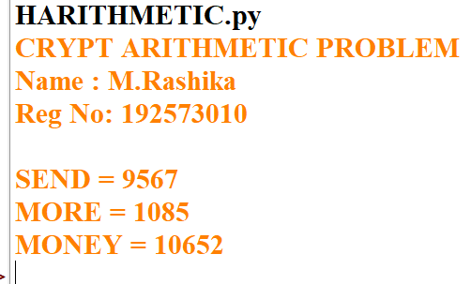

- 10. A* ALGORITHM

AIM
To implement the A* (A-Star) Search Algorithm in Python to find the shortest path from a start node to a goal node using heuristic values.
CODE
graph = {}
n = int(input("Enter number of nodes: "))

for i in range(n):
node = input("Node: ")
graph[node] = {}
e = int(input("Edges from " + node + ": "))
for j in range(e):
v = input("Connected node: ")
c = int(input("Cost: "))
graph[node][v] = c

h = {}
for i in graph:
h[i] = int(input("Heuristic of " + i + ": "))

start = input("Start node: ")
goal = input("Goal node: ")

open = [start]
cost = {start: 0}
parent = {start: None}

while open:
x = min(open, key=lambda i: cost[i] + h[i])
open.remove(x)

if x == goal:
path = []
while x:
path.append(x)
x = parent[x]
print("Path:", path[::-1])
break

for y in graph[x]:
g = cost[x] + graph[x][y]
if y not in cost or g < cost[y]:
cost[y] = g
parent[y] = x
open.append(y)

OUTPUT
